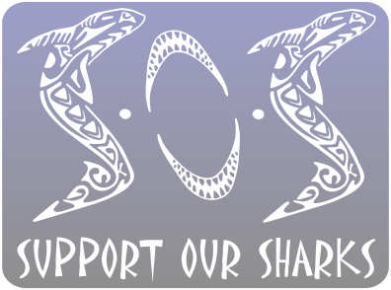
Support Our Sharks
Ocean Conservation Society

info@supportoursharks.com
WWW.SUPPORTOURSHARKS.COM

Media Release – Terms and Conditions

I, the OWNER of the supplied MEDIA, hereby irrevocably grants SUPPORT OUR SHARKS the right, but not the obligation, to use the MEDIA described in whole or in part, in any manner SUPPORT OUR SHARKS sees fit in the production of educational material (commercial and non-commercial) including, but not limited to, films, public displays, presentations, social media distribution and for use on the SUPPORT OUR SHARKS website. The OWNER shall provide this material at no cost. Full credit will be given to the OWNER whenever the material is used.

The OWNER warrants and represents that he/she has the right to grant all rights granted herein, and SUPPORT OUR SHARKS’ use of the MEDIA as permitted herein will not infringe on the rights of any third party. The OWNER will indemnify and hold SUPPORT OUR SHARKS harmless from and against any and all claims, damages, liabilities, costs and expenses arising out of any breach of the foregoing warranty.

